MATHEMATICS SPECIALIST

MAWA Year 12 Examination 2018

Calculator-free

Marking Key

© MAWA, 2018
Licence Agreement
This examination is Copyright but may be freely used within the school that purchases this licence.
- The items that are contained in this examination are to be used solely in the school for which they are purchased.
- They are not to be shared in any manner with a school which has not purchased their own licence.
- The items and the solutions/marking keys are to be kept confidentially and not copied or made available to anyone who is not a teacher at the school. Teachers may give feedback to students in the form of showing them how the work is marked but students are not to retain a copy of the paper or marking guide until the agreed release date stipulated in the purchasing agreement/licence.

The release date for this exam and marking scheme is
- the end of week 8 of term 2, 2018

Question 1 (4 marks)

Solution
Now $\vec{PQ}$ and $\vec{PR}$ . (note that $\vec{QR}$ )

As PQR is a straight line, these two vectors are parallel and are linearly related.

Inspection of the k components show that $\vec{PQ}$ = $\vec{ PR}$

Comparison of the i components gives .
Comparison of the j components gives

Mathematical behaviours | Marks
- calculates correctly two of the vectors $\vec{PQ}$, $\vec{PR}$ and $\vec{QR}$  - uses the k components of the two vectors to establish the linear relationship  - compares the first components to determine the value of b  - compares the second components to determine the value of a | 1  1  1  1

Question 2(a) (9 marks)

Solution
As clearly have that.
Also

Turning points at. Also and.
Function is zero at and

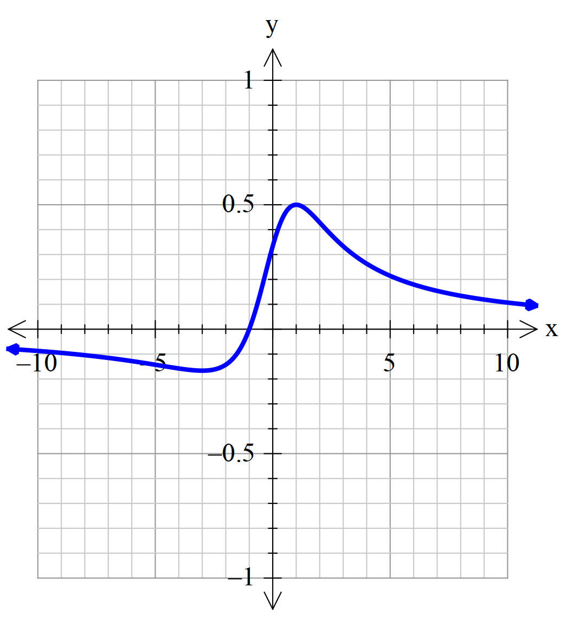

Mathematical behaviours | Marks
- identifies correct behaviour for large values of  - differentiates using the quotient rule  - identifies the co-ordinates of one turning point…..  - ……and of the other turning point  - identifies where function crosses the co-ordinate axes  - draws a neat sketch with a function with properly identified max/min…  - …….correct large behaviour…..  ……..and correct overall shape | 1  2  1  1  1  1  1  1

Question 2b(i) (3 marks)

- Solution
Denominator of the function is positive.
The part of the curve in (a) that was below the -axis is now reflected in the -axis

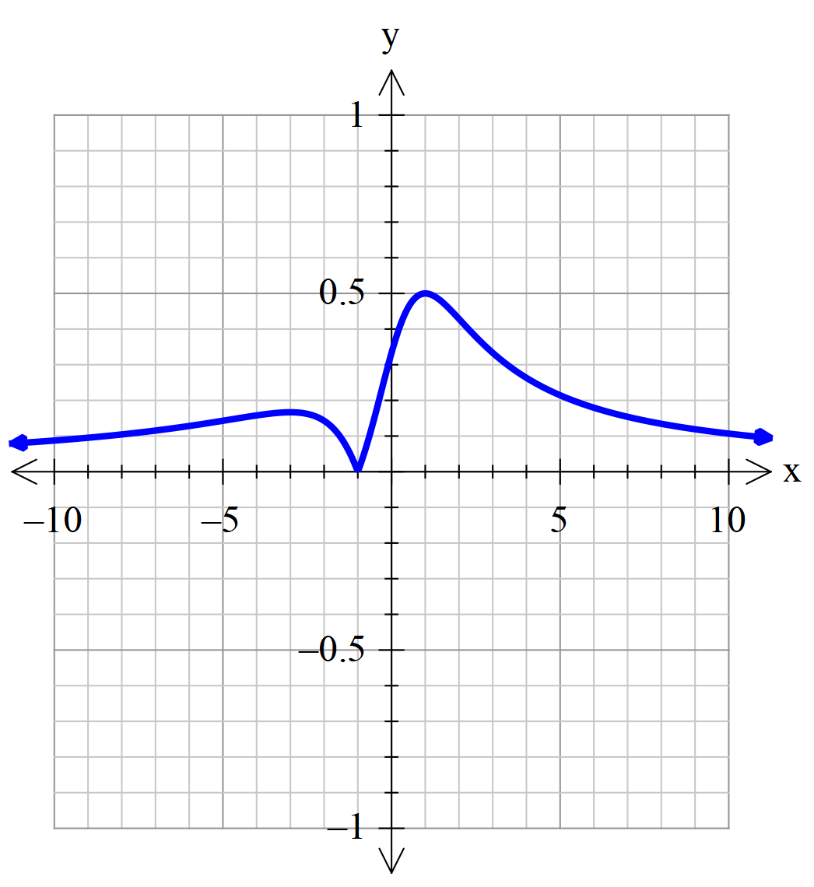

Mathematical behaviours | Marks
draws a sketch of the required function with evidence of  - recognising that  - the reflection of the part of the function lying in and  - a clear discontinuity in the slope of the graph either side of | 1  1  1

Question 2b(ii) (3 marks)

Solution
Function is now an even function since the denominator is clearly even.
The part of the curve in (a) that was to the right of the -axis is now reflected in the axis

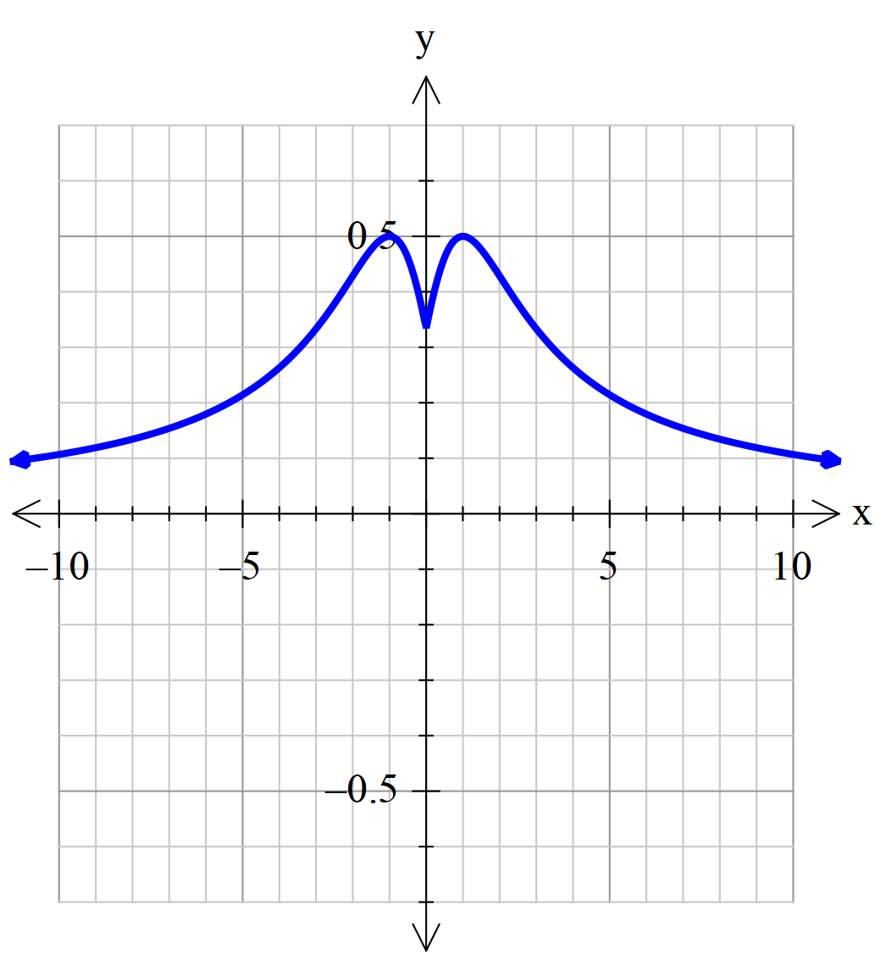

Mathematical behaviours | Marks
- indicates an appreciation that the modified function  - draws a neat sketch of the required function….  ..with evidence of the reflection of the part of the function lying in | 1  1  1

Question 3 (a) (2 marks)

Solution
Hence

Mathematical behaviours | Marks
- gives correct value for  - gives correct value for | 1  1

Question 3 (b) (3 marks)

Solution
and
Hence
Therefore

Mathematical behaviours | Marks
- states correct value of and  - deduces correct value of  - gives correct value of | 1  1  1

Question 4 (a) (2 marks)
Solution
The direction vector $\vec{AB}$

Thus required vector equation is r = i – j + k (i + j )

Mathematical behaviours | Marks
- calculates correctly the direction vector  - writes down an acceptable form of the vector line | 1  1

Question 4 (b) (2 marks)

Solution
The point on the line with the first component corresponds to

Then r = i j + k so that we have m=-8 and n=1.

Mathematical behaviours | Marks
- uses the given point to infer the value of  - hence deduces the correct values of m and n | 1  1

Question 4 (c) (2 marks)

Solution
If
Now the z-coordinate is constant so that the Cartesian equation is

Mathematical behaviours | Marks
- obtains the correct relationship between and  - deduces the correct equation including the property that is constant. | 1  1

Question 4 (d) (1 mark)

Solution
As the co-ordinate is constant, the line lies in the plane parallel to the -plane

Mathematical behaviours | Marks
- characterises the line as being parallel to the -plane | 1

Question 5 (a) (2 marks)
Solution
. Hence
Also the argument of lies in the second quadrant with

Mathematical behaviours | Marks
- states the correct value for 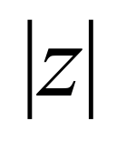  - gives the correct value for 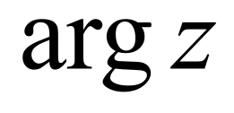 | 1  1

Question 5 (b) (3 marks)
Solution
From part (a) we know that cis and so cis
Now and so cis

So and .

Mathematical behaviours | Marks
- derives the result that  - observes that  - deduces the correct values of the real and imaginary parts | 1  1  1

Question 6 (a) (5 marks)

Solution
Consider the augmented matrix

Thus if the system will have a unique solution.

If then the third equation is inconsistent unless .
Hence no solution possible if and .

Mathematical behaviours | Marks
- sets up the augmented matrix  - performs correctly one relevant row operation  - performs correctly a second relevant row operation  - notes that has to have a particular value for no solution  - notes that in addition must be unequal to another critical value | 1  1  1  1  1

Question 6 (b) (2 marks)

Solution
If is to be a unique solution the third equation forces

Moreover we still need else the systems admits an infinity of solutions

Mathematical behaviours | Marks
- substitutes the given solution into the last equation to determine the connection between and  - adds the restriction on for otherwise the solution is not unique | 1  1

Question 7 (a) (3 marks)

Solution
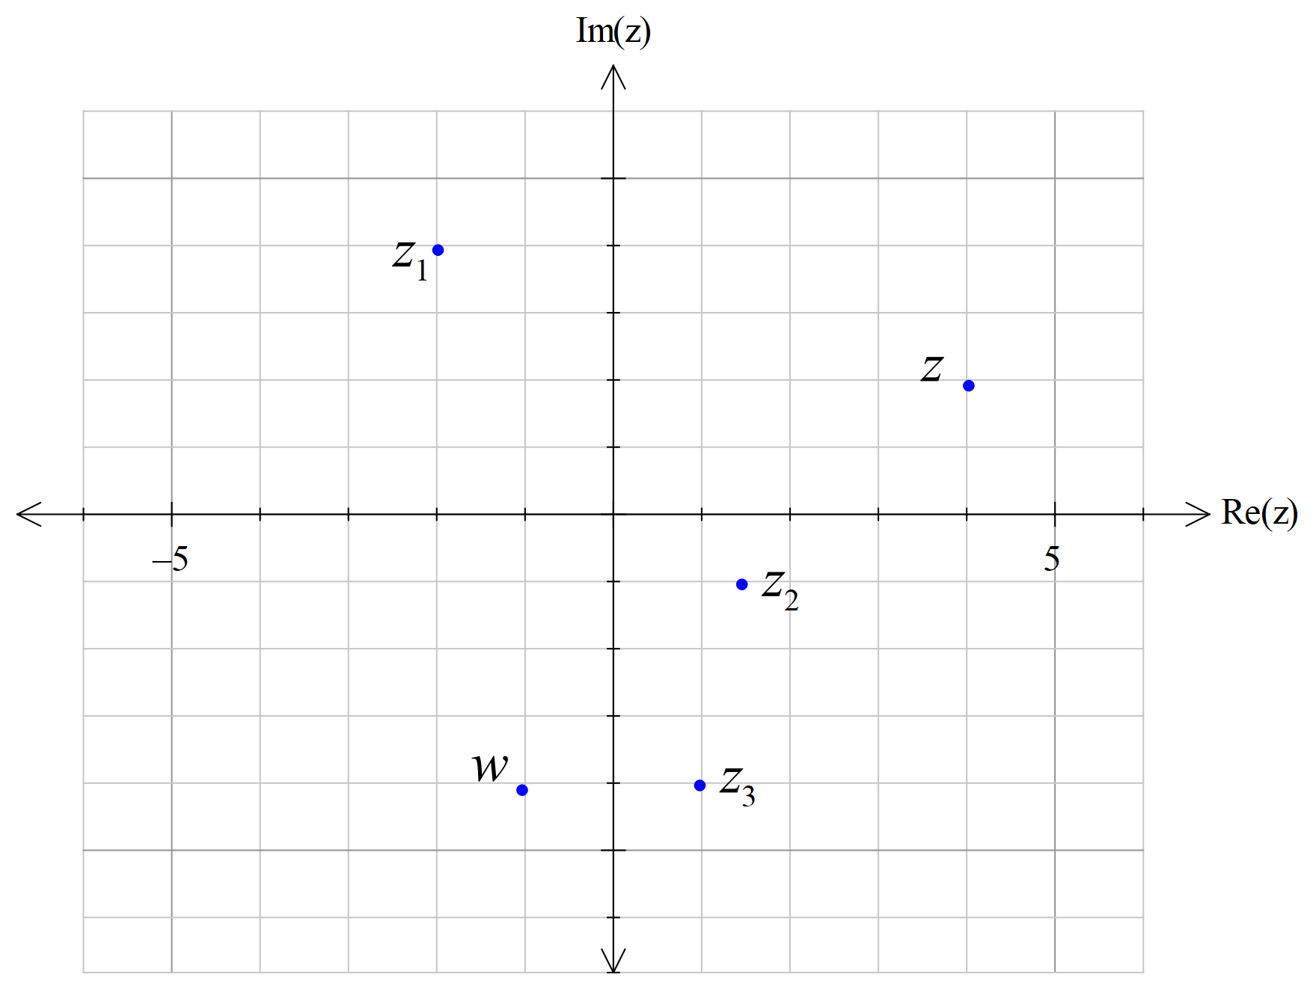

Mathematical behaviours | Marks
- plots correct location for  - plots correct location for  - plots correct location for | 1  1  1

Question 7 (b) (2 marks)

Solution
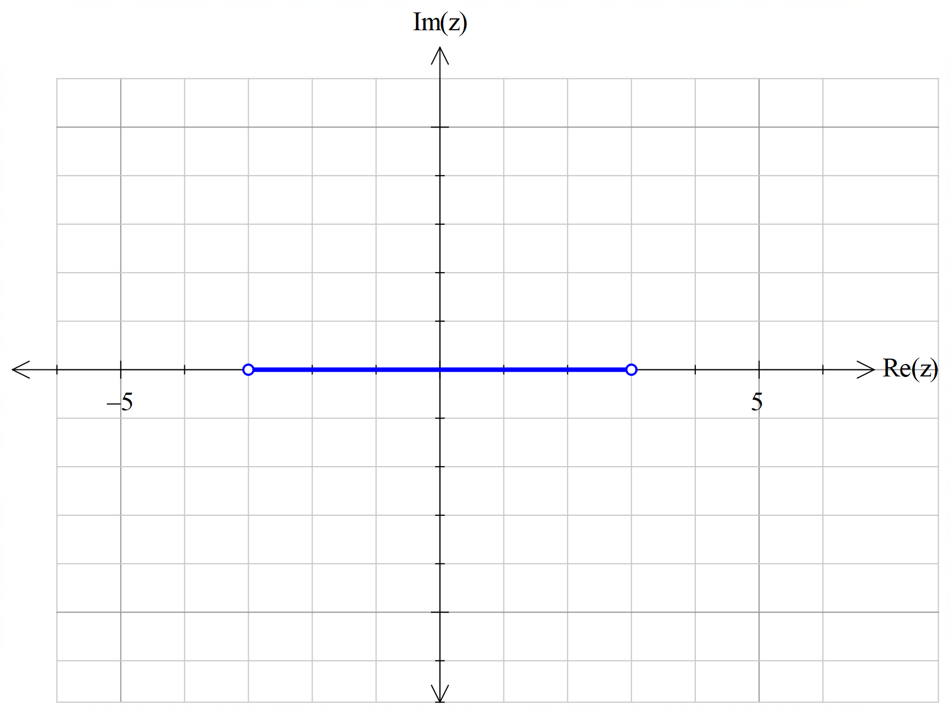

Mathematical behaviours | Marks
- shows a line segment  - plots the correct end-points and -3 and 3 (technically these end points are not in the domain as the argument of 0 is not defined – but no marks need be deducted for not discussing this) | 1  1

Question 7 (c) (2 marks)
Solution
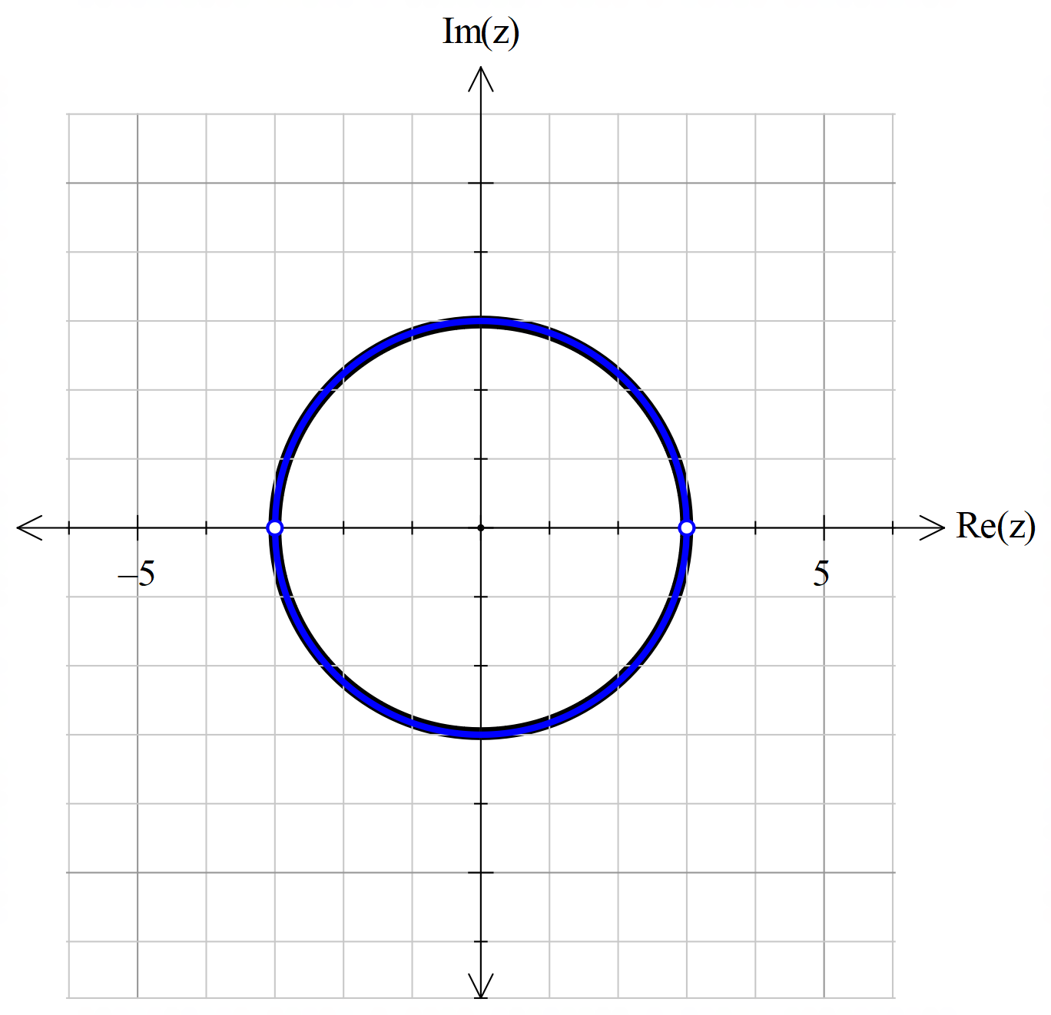

Mathematical behaviours | Marks
- plots a circular shape  - shows the correct centre at the origin and the radius 3 (again, technically, the points 3 and -3 are not in the domain) | 1  1

